Chapter #
Jazzed about Jing
Margarita Bianco
&
Dave McCollom

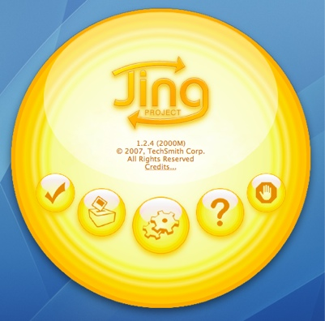
Technological advances have influenced the way we teach and how we communicate with our students; this is true for both traditional face-to-face courses as well as for online courses. Screen capture tools, such as Jing, can be used in a number of ways to facilitate learning and personalize communication (Griffis, 2009). In the following chapter we briefly explain what Jing is, how you might use it in the courses you teach, and conclude with some specific feedback of students perceptions of using Jing in both face-to-face and online learning environments.
Background
As an Assistant Professor in the School of Education and Human Development, I—Margarita Biano—teach in both the traditional face-to-face and online formats. I am always looking for ways to improve my teaching – especially with online instruction. I first learned about Jing in 2008 from a colleague who was raving about a free, new technology she learned about at a conference presentation. The word “free” caught my attention. I immediately downloaded Jing and within five minutes, I was creating my first screen capture and brainstorming all the ways I could use this technology with my teaching and research collaboration. I continued to use Jing more and more in the courses I teach. I have since been invited to share how I use Jing at a number of faculty development presentations as well as to contribute to this handbook.
When I was invited to write this chapter for the CU Online Handbook I thought it would be interesting to collaborate with Dave McCollom, the author of TechSmith’s Education Community Blog and a member of TechSmith’s Education Advisory Board. Dave’s technological expertise coupled with his experience training faculty and K-12 students around the world how to use Jing, provides great insight into how we can use Jing for teaching and learning.
What is Jing?
Jing is a free application that can be downloaded to your computer (Windows or Mac) from www.jingproject.com. Jing enables you to take screen captures (sometimes called screenshots) and annotate these static images of your computer screen. Jing also enables you to record short videos (5 minutes or less) of onscreen action (sometimes called Screencasts). You can then share screen captures and screencasts instantly with others—whether over the web, in instant messages, email, or even embedded in your online course shell. Jing’s companion site, screencast.com, makes sharing a breeze. Once your screen capture or screencast is complete, with a click of a button you can easily upload it to screencast.com. Once the upload is complete, Screencast.com copies the URL (to your screen capture or screencast) to the clipboard of your computer which you can then paste into an email or your course management system to share with students. Further, Screencast even provides HTML embed code for screencasts for you to directly embed the videos into your online course. But if you don’t want to use Screencast.com, you can simply save your screen captures as .png files and your sceencasts as SWF Flash video files and distribute as you see fit. Sound complicated? It really is not. The Jing Help Center (http://help.jingproject.com) has quick and easy video tutorials that will help with all Jing functions.
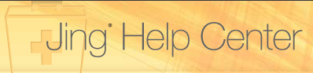
Once you get hooked on the free version of Jing, it will be just a matter of time before you start thinking about upgrading to the pro version called Jing Pro. Jing Pro costs $14.95 per year. But it provides some additional features that the free version does not. First with Jing Pro you get the option to include your webcam in screencasts so that part or all of the screencast can include a video of you. Jing Pro also uses a premium video format (MPEG-4 AVC) that is better at recording rich content from your screen. This video format also produces friendlier file sizes and can be edited in many standard video editing applications.
Teaching with Jing: The Perfect Companion
There are many ways to integrate Jing into traditional face-to-face or online instruction. Below are just a few of the ways that I, Margarita Bianco, have used Jing for teaching and communicating with students.
Introductions
In the first weeks of the semester I create a PowerPoint slideshow of family photos. I narrate and record the slides as I introduce my family and myself (which is essentially a digital story about me and my family). The Jing video is then uploaded to eCollege for students to access in the Introductions section of the course. Students are asked to do the same and provide a link to their screencast on the Introductions threaded discussion.
Answering Email
Sometimes typing out a detailed response to a student’s inquiry takes a long time. I will instead sometimes simply create a screen capture, with the student’s email on the screen and answer the student’s questions in a narrated video (in other words, a screencast); I have found that the response can be much more personal. By communicating like this, I can provide a personal and detailed response—and if needed, I demonstrate where to get more information (e.g. share a website) or how to perform a task (e.g. use the drop box in eCollege—the course management system used in our School).
Explaining Assignments and How To….
Jing is the perfect tool for explaining assignments and demonstrating “how to…” do almost anything. Assignment explanation is enhanced when students can see and hear the purpose of the assignment and how it will be evaluated. Screencasting images of a grading rubric while explaining each component of the assignment allows students to listen to the explanation as many times as needed. This alone has reduced the number of student emails I receive requesting assignment clarification by at least 75%!
Explaining “how to” becomes easier when students can watch as you demonstrate a process. For example, by creating short narrated videos, I can demonstrate how to use eCollege tools, conduct a literature search, or use APA. The value of using screencasting for this purpose is that it is easier to use for demonstration than explaining detailed processes in written form (Griffis, 2009).

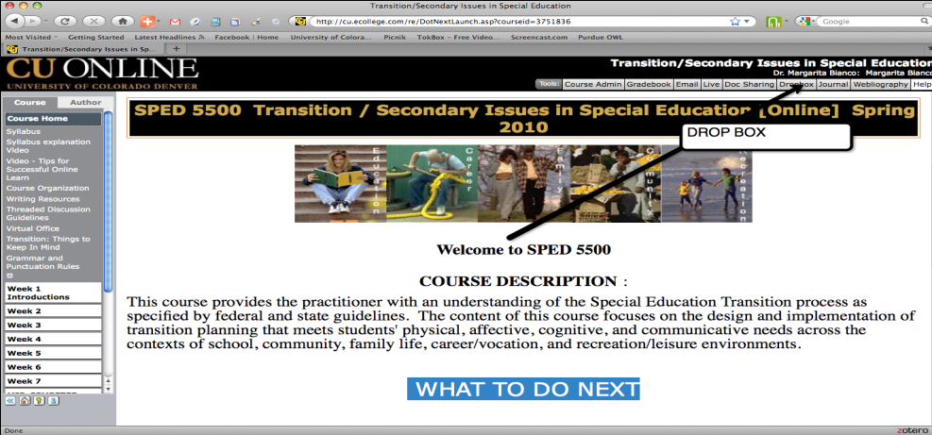

Introduce and Summarize the Week
For both my face-to-face and online classes, I like to provide a weekly introduction of the learning for the week by outlining key points to consider and keep in mind. Afterward, I like to provide a summary of what was learned by connecting discussions to readings and practice. I have found that creating a Jing screencast for these purposes saves me a lot of time. I no longer have to spend time typing lengthily emails several times a week. In just a few minutes, I can create a visually engaging summary of the week, send the link in an email or post the video online. The image below is a screenshot of a video summarizing students’ work on a case study we discussed.

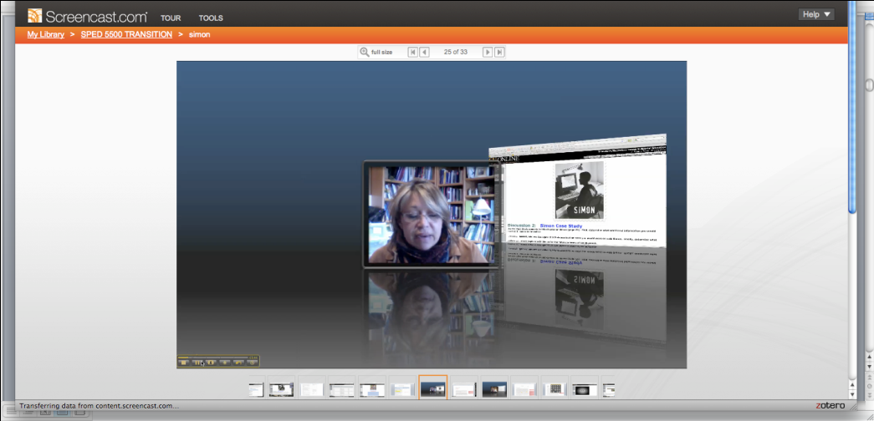

Feedback for Students
Perhaps my favorite way to use Jing is to provide detailed feedback on students’ written work. Typically I ask students to submit their work electronically and I provide feedback using the track changes function on Microsoft Word documents. Although I still do this, I now add a Jing clip too. After reading through the student’s work and commenting on content and professional presentation, I then create a screencast and essentially summarize my comments. Students are now able to see the written feedback and hear what I have to say about their work.

Explore Content Related Websites
How often do we crowd our syllabi with a list of related websites for students to explore – or simply send students a link to a website? Instead, by creating a Jing screencast you and your students can take a virtual tour of content related websites pointing out where to find the information they need to know.

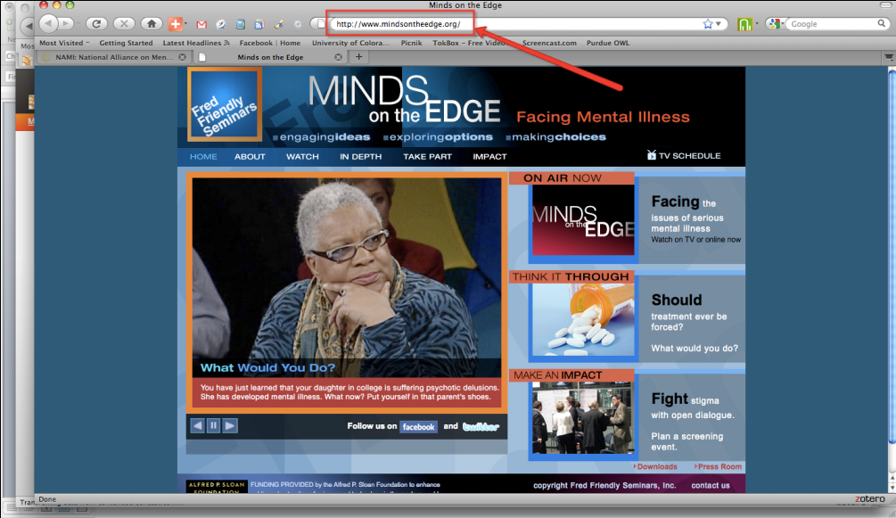

Advising
Finally, I have recently started to explore the utility of using Jing for student advising. I have created several Jing clips by sharing my screen with the student handbook and narrating students’ schedules, showing where to find internship forms, or outlining the requirements for their MA portfolio.
Students Use Jing Too
Although I have been using Jing as a teaching tool for more than one year, I have only recently started to require that students download the free version of Jing and include Jing projects as part of their course assignments. For example, students recently had to select one of 5 articles to read for one of my online courses. Instead of having them summarize the article and share a Word document or type their reactions to the article and post to a threaded discussion, students were required to create a Jing presentation to highlight what they learned. Students were encouraged to be creative in their presentation by using images and talking us through their learning.
Reflecting on the Student Experience
In order to improve my teaching, I frequently ask students for feedback on how effectively material was presented, the use of small / large group discussions, and on how screencasting with Jing has helped their learning. The following comments illustrate students’ perceptions of using Jing for a variety of purposes.
When asked about getting feedback on assignments by using Jing, one student in an online class shared the following:
Feedback on my assignments using Jing and hearing you talk is much more valuable than just getting back papers with track changes and written comments. The use of Jing has provided much more personal and detailed feedback and has allowed me to get information on the direction I should take with future assignments. It also eliminates -or at least decreases any confusion or questions I might have regarding what written comments refer to. [Kim Decker]

Another student in a face-to-face class humorously commented on how much easier it was to have his paper critiqued using Jing.

When you TORE into my paper it was nice to actually hear your voice and know what you wanted from me instead of marks on my paper. Instead of a marked up paper, or a typical "good job" and blowing off the hard work I put into it you actually gave me helpful insight on how to write a graduate level paper. You explained to me, in your own words, what you expected of me without telling me exactly what to write. You showed me my paper and scrolled through it and told me what I was lacking and asked me to become a critical thinker and writer. At first I was nervous about not doing so well on my paper, and then when you explained it to me, it gave me a whole new perspective and thought process of writing. This whole process was great because I did not have to worry about setting up an appointment to discuss my paper; instead it was thoroughly explained using Jing. [Christian Eaves]

Another student commented on the personal nature of using Jing for feedback

It’s way more personal to get feedback via Jing than just the written feedback on the documents. It made me feel good that you took the time to go the extra step in order to make sure that I understood your feedback.
I thought using Jing for our discussion group was really fun! I found that it was a more personal way to express my thoughts on the topic. And I really liked hearing others’ Jing clips, I was able to put a voice and a personality to all of my classmates that I have been interacting with all semester.
[Tracy Piniarczyk]

Students also comment on how the short video clips facilitate their learning.

The short videos further my learning by providing many of the benefits of a face-to-face course experience. Although it is an online class, the clips provide an opportunity for us to hear a real-life explanation of assignment expectations and discussion of course topics. Again, the use of Jing minimizes confusion and questions I would have otherwise. Along with Jing, the other uses of technology in this course, such as the video of panel members, have helped me to see how the course material should and can be applied to real-life situations and individuals.
…the Jing clips do give me a sense of closure from one week to the next, which is really nice. The Jing clips do a nice job of reflecting on the previous week and giving me a little direction for the next week.
[Tracy Piniarczyk]

One student commented on liking the visual aspects of Jing.

I like the “visual” aspect of Jing the most. When you have comments regarding assignments, I can see directly what you are referring to. I also like the little intro to each week’s assignments via Jing. I’ve also used the little intro to the assignments when I try to recall what you had said about a specific assignment and how you wanted it completed. Don’t get me wrong I like the “paper” syllabus and written instructions too. [Karen Minnotte]

Most importantly, however, students are beginning to think about how they can use Jing and other screencasting software in their own practice.

I teach student with significant support needs and I am always trying to find new ways to keep them engaged and involved in their learning. Some ideas I have had for incorporating Jing into my classroom: have students put together a power point of their community words with pictures and text and have them narrate the slides by saying the word, if we have a camera, using Jing to practice their interview skills so they can review and reflect on their interviewing skills. I also think this would be a really great way to get information to parents. For example, I just sent home a permission slip for some field trips coming up. How great would it be for the parents if they also received a Jing clip that has me describe the field trip permission slip, where they have to sign and more about what the field trips were about.
[Tracy Piniarczyk]

References
Griffis, P. (2009). Building pathfinders: Free screen capture tools. Information Technologies and Libraries, 28 (4), p. 189-190.
Folkestad, J.E. & De Miranda, M.A. (2001). Impact of screen-capture based instruction on student comprehension of computer aided design (DAC) software principles. Journal of Industrial Technology, 18(1), 1-7.
Steinweg, S.B., Williams, S. C, & Warren, S.H. (2006). Reaching through the screen: Using a tablet PC to provide feedback in online classes. Rural Special Education Quarterly, 25(2), p. 8-12.
Denton, P., Madden, J., Roberts, M. & Rowe, P. (2007). Student’s response to traditional and computer-assisted formative feedback: A comparative case study. British Journal of Educational Technology, 39(3), 485-5000.
MacDonlad, L & Caverly D.D. (2007), Techtalk: Screen Capturing. Journal of Developmental Education, 30 (3), 38-39.

Bio
Margarita Bianco is an Assistant Profession of Special Education at the University of Colorado Denver. She has nearly 20 years of classroom teaching experience, most of which was in urban settings working with students with disabilities and culturally and linguistically diverse student populations. Her research interests include gifted students from underrepresented populations including twice-exceptional and culturally and linguistically diverse learners. Dr. Bianco received the 2004 Council for Learning Disabilities (CLD) Outstanding Researcher Award for her research on the effects of disability labels on teachers’ recommendations for gifted programs.
Dave McCollom began at TechSmith as an IT specialist in 2006 before moving into his role as education evangelist. Currently, he works closely with users around the globe, specifically focusing on the educational markets. In his position, he conducts ongoing and direct conversations with customers in order to influence continuous product improvement. Dave’s outreach to the educational community includes attending conferences both in the U.S. and abroad as well as visiting schools and classrooms for one-on-one and group training sessions with educators.

Students’ permission was obtained and granted to include in this chapter.

