Chapter 11
Getting to Know You: The First Week
of Class and Beyond
Joanna C. Dunlap
&
Patrick R. Lowenthal
The first week of class… Whether on-campus or online, we always plan a few orientation and get-to-know-you activities in an attempt to get our courses off on the right foot. One thing we have learned about these types of activities is that they cannot—and should not—take place only during the first week of a class. To really support students and help build a productive online learning community, these types of activities need to occur throughout the semester. Below are a few activities we have used to help students get oriented to and familiar with the course structure and materials, their course colleagues, and us.
Orientation
In a face-to-face course, it can be deadly boring to spend the first class reading through the syllabus. However, there is important information in the syllabus that we want students to know and keep track of. In online courses, it can also be boring reading through the syllabus and other course materials and, therefore, we have found that students sometimes don’t go through all of the course materials as precisely as is needed to be successful in the course. Here are a few things we have done in our online courses to help students get oriented to the course.
Orientation Videos
One approach we use is to create a set of short (less than 5 minutes) orientation videos, with each video walking students through the course shell, learning activities, and projects. Using Jing, we have created screencasts showing our students around the course shell (see Chapter 10 for more uses of Jing). This is especially helpful for students who are new to online courses. In addition to the orientation benefits, our students are also oriented to us as their instructors because of our use of humor and stories while explaining various course design decisions
[should we include any links to examples? Do you have a good one?]
Course & Syllabus Scavenger Hunt
Using the quiz tool in our course management system, we set up a course and syllabus scavenger hunt that students have to submit by the end of the first week. To complete the 12-question scavenger hunt, students have to read the syllabus, locate materials in the course shell, and watch the orientation videos. The results of the scavenger hunt reassure us that students are locating and tracking important course information, and alerts us to any misconceptions or confusions that individual students have about the materials or the assignments. Example questions include:
- In your own words, what are the learning objectives for this course? What is the reason for listing the program competencies with the learning objectives?
- Why is "creative" part of the course title?
- There are four projects for the course: Presentation Makeover Magic, Job Aid Makeover Spectacular, Presentation Prowess, and Design Lessons Learned. Which project are you most looking forward to working on? Why?
- Why are the weekly agendas for each week's learning activities hidden at the start of the semester?
Weekly Announcements
At the start of each week (which in our online courses is Monday since we set up the weeks to go from Monday to Sunday in the course shell), we post a new announcement orienting students to the activities of the week. Even though this information exists elsewhere in the course, we like to provide a more personal announcement about the week. We start each announcement with a brief description of the past weekend’s events with a photo or two (usually of us with our families). Then we provide students with a reminder about how they should focus their time and energy during the week. We end each announcement with a reminder about how to connect with us, and a wish for a great week. These announcements can be done in the course shell using the Announcement feature, via email, or using a tool like Jing to create an audio and/or video announcement.
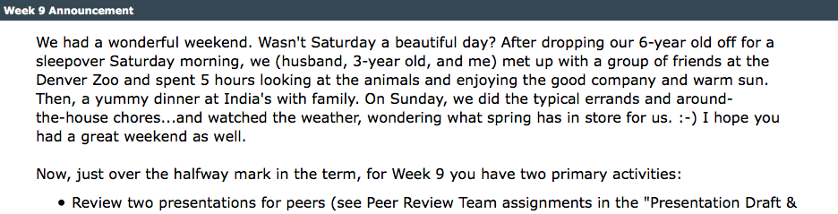
Weekly Agendas
For each week in the course, we have a weekly agenda checklist that students can print out to help them track what they should be working on during the week. Again, although this information exists in the course’s master calendar, it helps students to have the week’s activities laid out in checklist format.
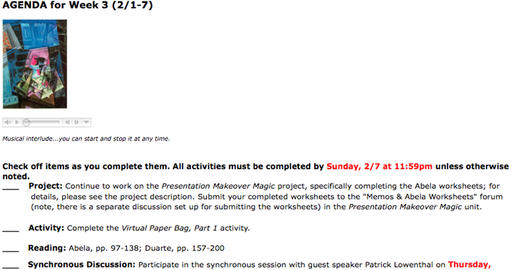
Getting To Know Each Other
We do not think it is very realistic to get to know people—especially in an online course—with one share-your-bio activity during the first week of class. Building relationships and community requires multiple opportunities to share and connect. So, every two to four weeks during the semester, we reengage students in getting-to-know-you activities. Below are a few of the activities we use in our online courses.
Superhero Powers
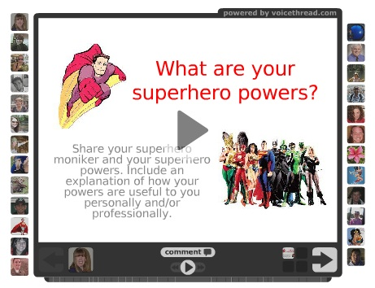
For this activity, using VoiceThread, students share a photo and record their response to the following prompt:
What are your superhero powers? What is your superhero moniker? And, how do your superhero powers help you in life?
Their creative responses are so fun…and the results are that we really learn about the assets that each person sees as her or his strengths. It is a very positive approach to a typical share-your-bio activity that also results in learning more about each person’s playful side and creative spirit.
Virtual Paper Bag
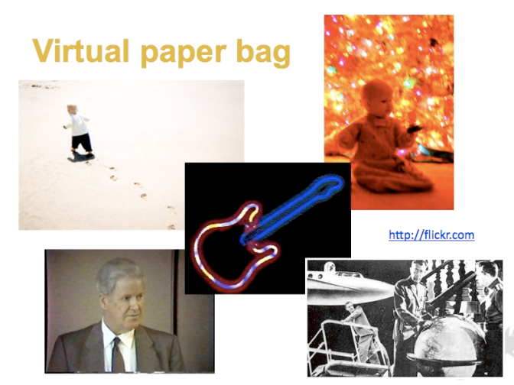
For this activity, we ask students to each pick five items that represent who they are and what is important to them. They pull together visual representations of their five items for a virtual paper bag, posting their five images to Flickr (or another tool of their choosing, as long as the rest of the class could easily access their collection in the end). Once everyone has posted their virtual paper bag collection of images, students review each other’s collections, and engage in a discussion of why those items were selected and what the items "mean". The results are that students learn about each other’s passions, values, families, and the like; learn about differences and similarities; and learn each other’s stories. This activity helps students feel more connected then they did before. And they remember details about each other because of the items and stories since there is emotion involved in the sharing.
“If You Were a Tree” Wordle
Similar to the virtual paper bag activity, for this activity we ask students to create a Wordle word cloud using 20 words that represents who they are. This activity encourages students to reflect on how they define themselves, and then to represent those definitions using only 20 words. Students then review each other’s word clouds, and discuss the commonalities, differences, and surprises.
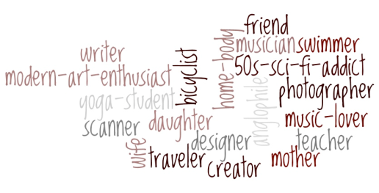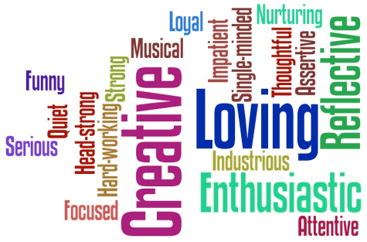
Soundtrack of Your Life
As another way for students to get to know each other, we ask students to share music. For example, we ask them to share one song that inspires and motivates them; or create a playlist of six songs: two that represent their past, two that represent their present, and two that represent their planned/hoped for future. After students share their music, the group asks questions about the selections – similar to a 20-questions activity – to figure out why each student selected the song(s) she or he did. The students consider the group’s shared interests, differences, and so on (e.g., how many folks like jazz, or female songwriters, or sad songs). We use tools such as Songza, Blip.fm, playlist.com, and Grooveshark for this activity, but there are many digital jukebox tools out there from which to choose.
A 5-minute Conversation
During the first few weeks of our online courses, we invite students to participate in a 5-minute phone conversation. Although it is an opportunity for students to ask questions about the course, the only agenda for the conversation is that we must hear each other laugh. We do this so that the students feel more connected to and less distant from us. About half of the students typically take us up on the invitation at the beginning of the course, although – with frequent reminders that the invitation still stands – we often end up talking with most if not everyone in the course at some point in the semester.
With a Cherry on Top
After all of the getting-to-know-you activities throughout the semester, we like to end courses with an experience that celebrates (1) what we have accomplished in the course as individuals and collaborators and (2) the success of our learning community and our established friendships. One activity we like that achieves these two objectives is what we refer to as Lessons Learned. For example, in the Creative Designs for Instructional Materials course, students are given the following directions:
- Consider what you have learned about the creative design of instructional materials. What are you sure about? What do you believe now? What advice/words of wisdom do others need to know about?
- Pick one of those design lessons learned and write it down. Design it digitally. Photograph it. Draw it. Use paint, sculpture, whatever. I don’t care as long as it’s interesting.
- Post a digital photo of your creation to our Flickr group account at http://www.flickr.com/groups/it6710fall2009/
- Write up an explanation supporting your design, and post it to this project’s discussion forum.
Using Flickr, students post their visual representations of a lesson they have learned from the course. This is a fun and creative way to close out a course experience, and the collection of lessons learned becomes a valuable take-away from the course and from our time together. And, it offers one more chance to connect with each other and get to know a bit more about each other’s perspectives and values.

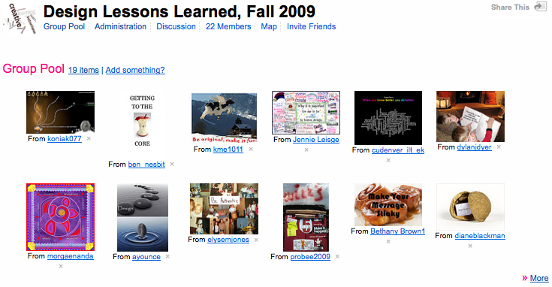

Conclusion
jlfjdlajfldjalfjdljafljdlajfl

Bio
Dr. Joanna Dunlap is an associate professor of instructional design and technology at the University of Colorado Denver. An award-winning educator, her teaching and research interest’s focus on the use of sociocultural approaches to enhance adult learners’ development and experience in postsecondary settings. For over 13 years, she has directed, designed, delivered and facilitated distance and eLearning educational opportunities for a variety of audiences. She also works in the Center for Faculty Development as the Faculty Fellow for Teaching, sharing ideas about teaching with online and on-campus faculty across the university.

Patrick Lowenthal is an Academic Technology Coordinator at CU Online at the University of Colorado Denver. He is also a doctoral student studying instructional design and technology in the School of Education and Human Development. His research interests focus on instructional communication, with a specific focus on social and teaching presence, in online and face-to-face environments. In addition, he often writes about issues and problems of practice related to post-secondary education. He has a MA in Instructional Design and Technology as well as a MA in the Academic Study of Religion. Patrick has been teaching and designing instruction since 1998 and teaching online since 2003.

