Chapter # (tbd)
xtranormal title needed
Stephanie Townsend
I often strive to incorporate activities in my courses that are authentic and relevant to my student’s lives and/or professions. Last semester I was teaching a master’s level course on children’s literature. With this course, I wanted to have my graduate students respond to literature much like they request students in their own classrooms to do. Given Rosenblatt’s theory on literature response, I thought providing an opportunity for the teachers to use xtranormal might spark their right brain and motivate and excite them. In the following paragraphs, I will briefly explain what Xtranormal is, how I used it, and how you might use it in your own classrooms.
What is xtranormal?
xtranormal (http://www.xtranormal.com), according to its website, is a “revolutionary, real time, movie making software.” And while this is true, I would describe xtranormal as a free Web 2.0 application that enables users to turn text into a movie. So basically if you can type, you can make an Xtranormal movie. You start by deciding how many actors you want, you then write the script, design the scene, and direct the action. In a matter of minutes, you can convert text into a movie and then share it with the world.
How I Use xtranormal
As neat as xtranormal is, I wasn’t going to use it in my classes if I couldn’t find a meaningful way to use it that supported my learning objectives. I use threaded discussions a lot in my online and hybrid courses for students to discuss certain topics. But rather than setting up a typical threaded discussion in which students discuss children’s literature, this particular week I asked my graduate students to select a favorite children’s book from our reading list and create a book talk using xtranormal.
I had them post the URLs to their xtranormal book talks in a threaded discussion and then asked them to each other’s book talks. My students were intrigued by
xtranormal. They repeatedly expressed the entertaining aspect of creating a short movie clip using xtranormal. See Table 1 for several favorite xtranormal clips from the children’s literature class you might enjoy.
Other Instructional Uses of xtranormal
Based on my experience and students reactions to xtranormal, I have been thinking about other instructional uses of xtranormal.
- Faculty can use xtranormal for a reading response and so much more.
- I think this would be an excellent site to use to teach writing, too. As I viewed the clips, I could hear the actual voices of these students. That is to say their “writing voice” is definitely evident.
- Another fantastic way to use this application would be to have students summarize key concepts in their reading. This would be much more inviting than outlining key concepts from texts and it might encourage students to actually watch the reading summarizes of others.
- I also see the benefit of teaching spelling in context with xtranormal. For example, if you type in “read” but the character does not say the word in past tense and you want the past tense of read, you will need to think of a word that sounds like the past tense and write it. In this case, you can type “red” and the character will read “red” which sounds like the past tense of read. Tricky and yet such a powerful tool to use spelling in context.
- I also think this could be a group project where a small group of three works on creating their own story with script, movements, background, and music to accompany the storyline.
- Perhaps after a Read Aloud to students, you could have them create multiple endings of the story using xtranormal.com and later read the actual end of the story. Comparing and contrasting what the students created and the actual ending might be interesting and provide for creative and critical thinking.
- You could also use this as a way to introduce a week or unit in an online course. I’m sure students would pay attention to these characters rather than me sitting in front of them giving directions.

Table 1. Xtranormal Book Talks
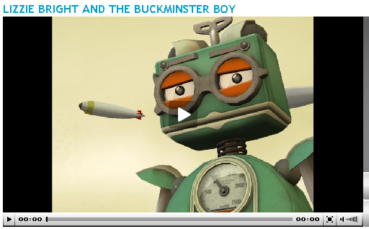 | Insert title of book?  http://www.xtranormal.com/watch/5631103
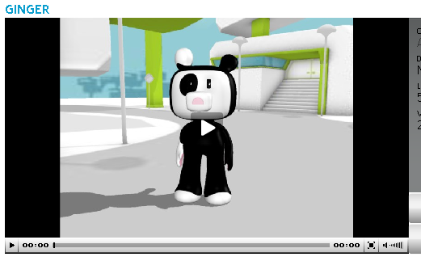 | http://www.xtranormal.com/watch/5649815/
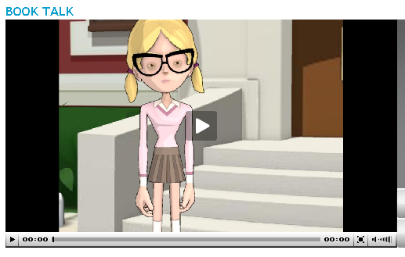 | http://www.xtranormal.com/watch/5658057/
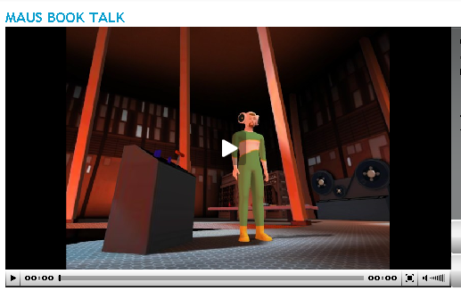 | http://www.xtranormal.com/watch/5668007

Conclusion
I am certain you will think of additional opportunities to use xtranormal.com. Enjoy the site.

References
…

Bio
Need a bio

