Chapter # (tbd)
Using Reflections Surveys to Improve
Teaching and Learning
Jackie Dobrovolny
&
Patrick R. Lowenthal
Faculty are being held accountable these days for quality teaching and student learning, as well as student satisfaction. While research and publishing are in many ways still the sine qua non for faculty success and promotion as well as institutional prestige, more emphasis is being placed on quality teaching these days than ever before. At the University of Colorado Denver, like many other institutions, end-of-course student evaluations (that is, FCQ’s) are one of, and unfortunately more often than not, the most used method to assess how well an individual faculty member is teaching. These evaluations though suffer from a number of weaknesses. For instance, … elaborate on weaknesses in the literature. While they do a decent job of measuring student satisfaction, in many ways, that is all they measure. To make matters worse, faculty often do not receive their FCQ’s for weeks, if not months after the semester—which is too late to fix the problem with the course in question. Instead, faculty have to simply try to make adjustments to their course and their teaching for the next time they teach it. One problem with this is that every group of students is a bit different; some groups of students struggle with different things than other groups. To address this problem, we began using reflection surveys in our courses. And to our surprise, reflection survey’s not only help us address student satisfaction issues like FCQ’s do in a more timely manner, we have also found that they have helped improve our teaching as well student learning. We will address in the following chapter how we use reflection surveys, some lessons we have learned, and some tips for ways you can use reflection surveys in your courses.
How We Use Reflection Surveys
ddd
Lessons Learned / Benefits
Ddd

Tips on Integrating Reflection Surveys into Your Course
ddd

--Timing (how often)
--Short surveys
--Identifying themes
--Option to be anonymous
--Focus on content as well as satisfaction and affect
--Public viewing of results
--Q&A if needed

Other thoughts…
--end of course evaluation as a different type of
--tools to use (surveymonkey, zoomerang, survey tool in blackboard, googledocs)
--polls as an alternative
--quantitative questions to get quick answers
--importance of feedback for students
--improving instructor’s social presence and perceived responsiveness

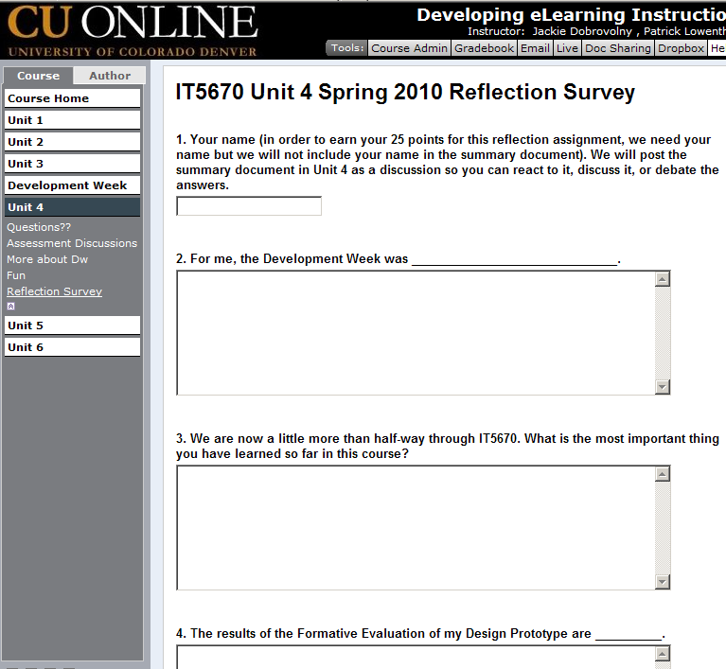
References

Bio
Add a bio about yourself. Garamond 10 pt fon

