Chapter 19
Lecture Capture Made Easy with Panopto
David Paul

At the Anschutz Medical Campus at the University of Colorado Denver, faculty and students alike for some time were requesting an easy way to record face-to-face classroom lectures. As a result, Educational Support Services (ESS) staff at the Anschutz Medical Campus began researching different lecture capture platforms (also known as lecture recording systems). The following paragraphs describe the process we went through, the benefits of Panopto and how faculty are using it across the university.

What is Lecture Capture?
If you are new to the term, “Lecture Capture” is “an umbrella term describing any technology that allows instructors to record what happens in their classrooms and make it available digitally” (Educause, 2008). So while there are a range of applications available to simply record what happens in a classroom, most of the time when people talk about lecture capture they are actually talking about lecture capture enterprise level platforms implemented across a school, college or university to record classroom lectures. [For more about Lecture Capture see Educause’ “7 Things you should know about… Lecture Capture” at http://net.educause.edu/ir/library/pdf/ELI7044.pdf (Educause, 2008).]

Why Panopto?
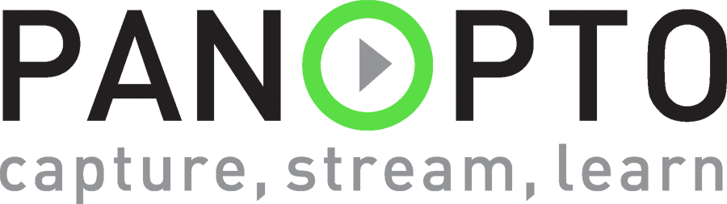
There are many - different Lecture Capture platforms to chose from. Popular names include Tegrity, Camtasia Relay, and Echo360, and Accordant. In addition to Panopto, we tested Accordant, and Echo 360. Other systems we dismissed because they didn’t’ fit in with our configuration or reauired criteria. Each of these platforms have some strengths and weaknesses. In the end we end, we chose to license Panopto (http://www.panopto.com) because we were looking for a lecture capture platform that:
- Runs on computers already installed in classrooms
- Was easy for faculty to operate
- Required a minimum of technical staff support
- Could be automated to start and end automatically
- Interfaced with our LMS (Blackboard)
- Was reasonably priced…

How it Works
nearly every classroom on the Anschutz Medical Campus is set up with Panopto—which basically means there is at least one camera, a microphone, and a computer. To record a lecture, the instructor, or a student assistant starts the program, selects the correct course, verifies that they have a good video and audio signal via the preview window, clicks on the big red “Record” button, and then continues to teach their class as they normally would. Once they are finished, the bring the Panopto window back up and click on the “Stop Recording button. Their lecture is automatically uploaded to the server, endoded and a URL to the recording can then be distributed to students via email or posted in a Learning Management System (e.g., eCollege or Blackboard). In fact, faculty who use Blackboard on our campuses benefit from Panopto’s Blackboard building block which allows students to access the Panopto recordings for their class through the corresponding Blackboard course shell. Links to recordings are automatically uploaded to the Blackboard server as soon as they are completed. In addition to recording and distributing lectures, Panopto also has reporting features. This allows instructors and administrators to see how often their students are watching the recordings, and can provide details on an individual student. It can even tell you which part of the recordings students are watching.
For a more detailed demonstration of the system, click on the image below or simply go to: http://coursecast.ucdenver.edu/CourseCast/Viewer/Default.aspx?id=02095990-acd1-4f67-811a-0030d6b37a23

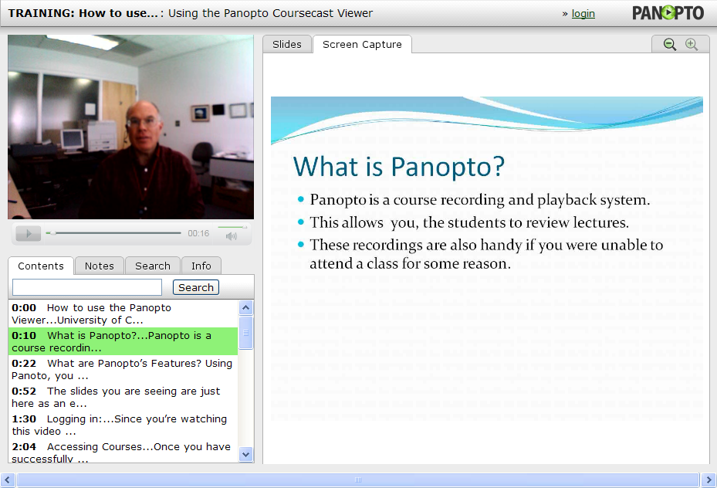

How it’s Used
While lecture capture systems like Panopto can be used in a number of different ways, most faculty who use Panopto simply use it to record lectures they are already giving in a face-to-face setting. For instance, in the Schools of Medicine and Pharmacy, literally every class is recorded.
The recordings allow students to review classes or to view classes if they are absent. If a student doesn’t remember the session a particular subject was covered, they can search by keywords because all of the PowerPoint slides are captured and indexed.

Moving Forward with Panopto
Implementing Panopto on the Anschutz Medical Campus has been a success. Certain programs have even hired student technology assistants to handle the recording duties, as well as assisting instructors with technical issues in the classroom. This approach has been very successful, ensuring high quality recordings, without the need for hiring additional staff. If you have any questions about Panopto, please contact Paul Herndon or David Paul.

Bio
David…
David Paul has been working with academic technology since 1986. He is currently the Manager of Educational Technology at the University of Colorado Denver, primarily at the Anschutz Medical Campus (AMC). He has offered numerous workshops and presentations on Learning Management Systems, Classroom Lecture Capture, Audience Response Systems and other technology tools for educators. David has been at the University of Colorado since 1993 and enjoys working with students, faculty and staff to leverage educational technology in the classroom. David and his staff also manage the computer labs on both the CU Denver downtown and medical campuses, as well as supporting test processing, course/faculty evaluations, room scheduling and computer-based web conferencing at the AMC.

